
GHANA REVENUE AUTHORITY



DOMESTIC TAX REVENUE DIVISION

PERSONAL INCOME TAX RETURN

 |  | CURRENT TAX OFFICE |  |  |  | LTO |  |  | MTO |  | STO
 |  |  |  |  |  |  |  | (Tick One) |  |  |  |  |  |  |  |  |  | Name of GRA Office
 |  | YEAR OF ASSESSMENT
 |  |  |  |  |  |  |  |  | (yyyy)
 |  | PERIOD: |  |  | FROM |  |  |  |  |  |  | TO
 |  |  |  |  |  |  |  | (dd / mm) |  |  |  |  |  |  |  |  |  | (dd / mm)
 | (Please refer to the completion notes overleaf for guidance in completing this form)
1. PERSONAL INFORMATION
SURNAME |  |  |  |  |  |  |  |  | TIN
FIRST NAME |  |  |  |  |  |  |  |  | TELEPHONE NO.
OTHER NAME(S)
NATIONALITY

2. BUSINESS INFORMATION
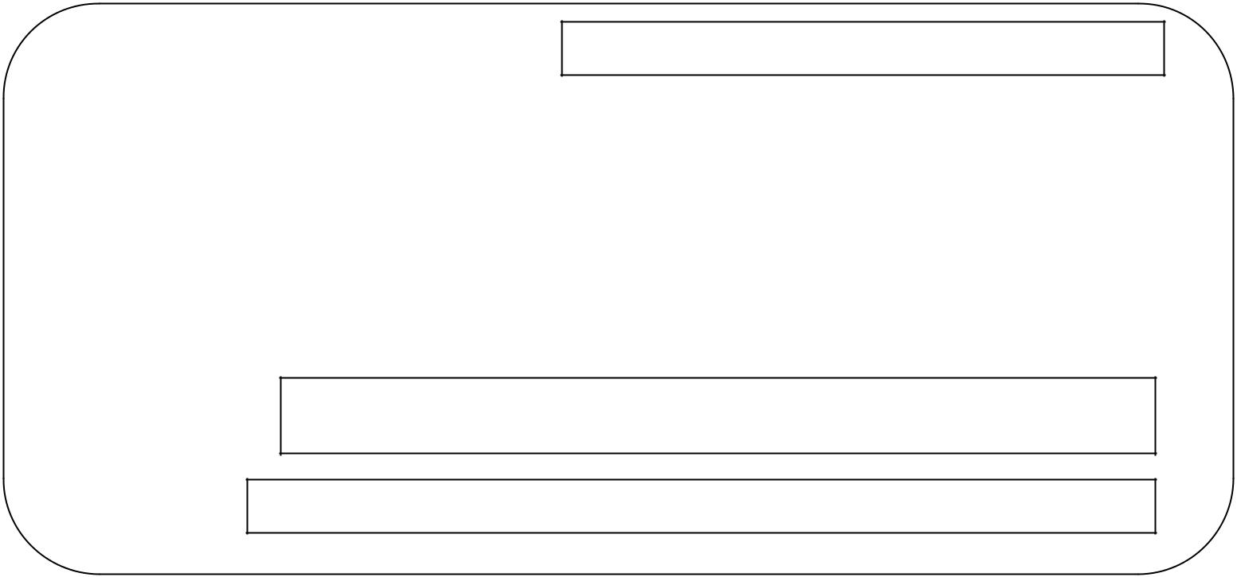

LOCATION/GHANAPOST DIGITAL ADDRESS

BUSINESS NAME(S) |  |  |  |  | BUSINESS ACTIVITY
If more than ONE provide the same information on a separate sheet
Tenancy status of Business Rented |  |  | Owned |  |  | (If rented provide particulars of Landlord)
Name of Landlord

Telephone Number(s)

TIN

3. EMPLOYMENT INFORMATION

TIN OF EMPLOYER

NAME OF EMPLOYER

ADDRESS

DT 0103 ver 1.1 LZ H/A STO

- SOURCES OF INCOME



(Do you earn income from business? If No proceed to B)

- NET BUSINESS INCOME/LOSS (As per financial Statement attached)

(Do you earn income from employment? If No proceed to C)

- EMPLOYMENT INCOME

  - Basic salary

    - Cash Allowances

    - Other Cash Benefit

    - Excess Bonus

Benefit in Kind

1.Accommodation Benefit

  - Vehicle Benefit

  - Others e.g. Loan Benefit & Share Benefit etc.’

- Total Benefits in kind (The sum of 1,2 and 3)

vii. Others (e.g. Director’s Fees)

TOTAL EMPLOYMENT INCOME ( Sum i to vi)

Do you any investment income?

(If No proceed to D)

- INVESTMENT AND OTHER INCOMES

  - Royalty

  - Interest

    - Dividend (Received from Non-Resident Person)

      - Taxable Rent Income (See Notes)

      - Income from Foreign Source

      - Other ( e.g. Premium, Annuity, Discount etc.)

TOTAL INVESTMENT INCOME & OTHER INCOMES (Sum i to vi)

(Business, Employment Investment & Other Income)

D. TOTAL INCOME (Sum A, B, and C)

DT 0103 ver 1.1 LZ H/A STO


5. TAX COMPUTATION

A. NET BUSINESS PROFIT/LOSS ( Same as 4A )

Add Backs

  - Depreciation

  - Non –allowable deductions

- Total Add Backs (sum i and ii )

- ADJUSTED BUSINESS PROFIT/LOSS (Sum A and B)

Deduct :

    - Non- Taxable income

  - Allowable Deduction (Capital Allowance, Carry Forward Losses etc.)

- TOTAL DEDUCTIONS ( sum i and ii )

- NET ADJUSTED BUSINESS PROFIT/LOSS (E=C-D)

- ADD TOTAL INVESTMENT INCOME (same as 4C)

G. ADD TOTALEMPLOYMENT INCOME (same as 4B)

H. TOTAL ASSESSABLE INCOME (sum 5E,5F, and 5G)

LESS:

I. INCOME TAXED AT DIFFERENT RATES

J. NET ASSESSABLE INCOME ( 5H Minus 5I)

DEDUCT: RELIEFS

i. Social Security

- Marriage / Responsibility

- Children’s education (up to 3 Children)

- Old Age (For employees aged 60 years above)

- Aged Dependents (up to 2 aged dependants.)

vi Disability

vii. Cost of Training

.

  - Voluntary Pension contribution (3rd tier provident fund)

  - Other allowable deductions

- Total allowable deductions/reliefs (Sum of i to ix)

DT 0103 ver 1.1 LZ H/A STO


L. CHARGEABLE INCOME ( 5J – 5K)

M. Tax Charged

. Less PAYMENTS

i. Tax Credits

ii. Payment on Account (All Sources)

N. TOTAL PAYMENTS (Sum of i to ii)

O. TAX PAYABLE / (OVERPAID) (M-N)

DECLARATION
- For persons making return on their own behalf

I , |  |  |  | do hereby declare that the information contained in this
return to the best of my knowledge is true, correct and complete.
Signature |  |  |  |  | OR
Date |  |  |  |  |  | R.T.P

- For persons making return on behalf of another person

I |  | on behalf of

do hereby declare that the information contained in this return to the best of my knowledge is true, correct and complete. Address

Signature

Relationship to taxpayer

Date

DT 0103 ver 1.1 LZ H/A STO

